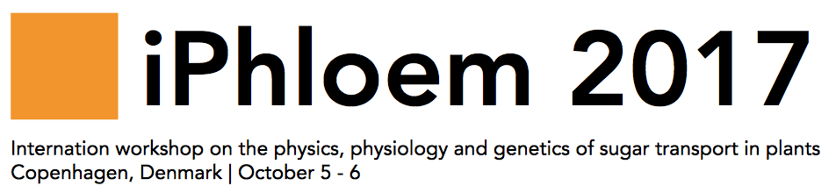
A descriptive title for interesting results, at most two lines (Times New Roman 16 pt)

Presenting Author¹, One Coauthor^{1,2}, and Another Coauthor² (Times New Roman 13 pt)

¹Department of Plant Science, University of So and so, Firstcity, Firstcountry (Times New Roman 11 pt)
E-mail: P. Author@univsound.edu, URL: http://www.iphloem.org
²Department of Physics, Wet University, Secondcity, Second country

Length and formatting of the abstract
An abstract for iPhloem 2017 is limited to one A4 pages with 2-cm-margins on all sides, and written in font size 11 pt.

Abstract (Times New Roman 11 pt for section headlines and main text)
In this short introduction to your 1-page abstract for iPhloem 2017, you should briefly introduce the context of your study. Describe the aim of the work, and mention whether this is an experimental and/or theoretical and/or numerical study. A few references to important prior work in the literature could be given [1,2]. End by highlighting the most important results.

Results
A few references to important prior work in the literature could be given [1,2]. See Fig. 1 and its four sub-figures for a new interesting observation, which seems to contradict other published data [3,4]. A paragraph with more words. A paragraph with more words. A paragraph with more words. A paragraph with more words. A paragraph with more words. A paragraph with more words. A paragraph with more words. A paragraph with more words. A paragraph with more words. A paragraph with more words.

Conclusion
We have found some amazing results, which we are looking forward to presenting at iPhloem 2017 at DTU, Kongens Lyngby, Denmark on 5-6 October 2017.

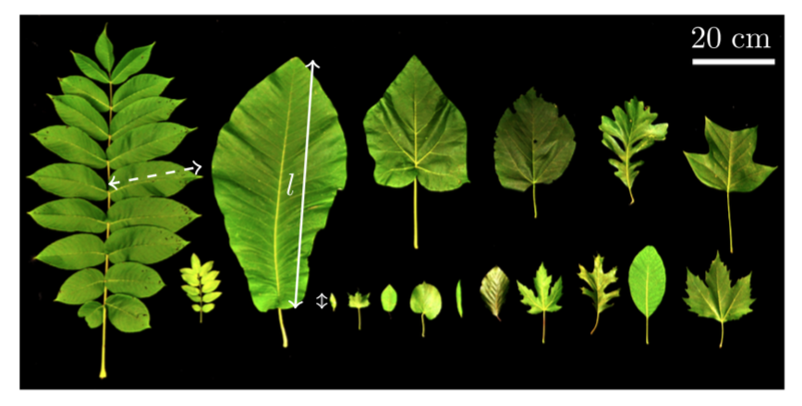 | Figure 1: Perhaps you want the caption to the right of the figure, then follow the setup defined here. Note that the font size of the caption is 10 pt which is smaller than the 11 pt of the main text. (a) Description of the first sub-figure. (b) The next sub-figure. (c) The third sub-figure. (d) Last but not least, the fourth sub-figure.  For Word users: This figure is placed in a 1×2 Table with invisible borders. Be careful not to delete this table environment during edits.

References (Times New Roman 10 pt)
[1] P. Author, O. Coauthor, and A. Coauthor. Journal Name 12, 4617-4627 (2012).
[2] O. Coauthor and A. Coauthor. Another Journal 324, 461-512 (2014).
[3] P. Author. A book title, Publishing Company (Publishing City, 2015).
[4] A. Coauthor. Procs. pp. 124-127, Some International Conference, Conference City, 1 - 6 July 2014.

